# Job Aid: How Students Can Access Recordings in Engageli

## Enter the Playback Room

Use your usual class link and select “Join My Playback Room” or “Playback room” at the top of the login screen.

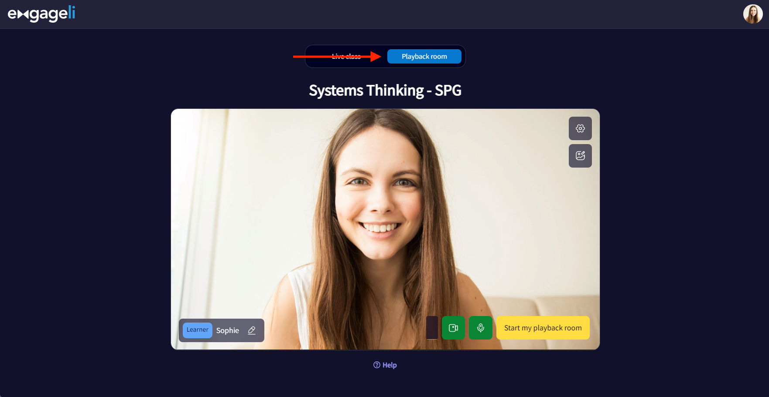

## Locate and Play the Recording

You’ll see a welcome screen alongside a list of session recordings in the Learning Path panel on the right. Click a video title, then hit play in the center of the playback player.

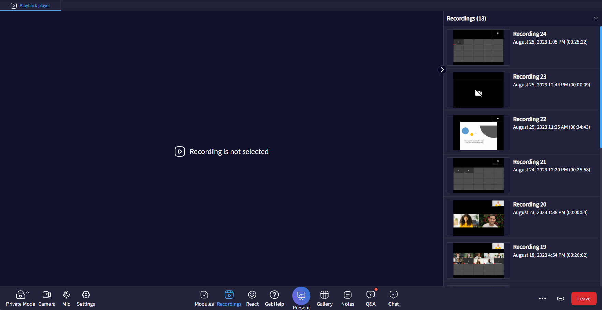

## Use Playback Controls & Learn Features

You can play, pause, fast-forward, rewind, and track your watch progress through a green timeline indicator. Interact with embedded tools—polls, Replay Chat, Notes, Q&A, transcript, whiteboard, PDF share, and reactions/sounds.

## Access and Interact with Shared Documents

If a file was shared during the live session, look for a blue marker on the playback timeline. Clicking it opens the document in a new tab—pause playback to view or edit.

## Adjust Room Settings

Use the Settings menu to change audio and video, enable closed captions, and modify appearance preferences.